1) Dockerfile with Ubuntu OS and dependencies

created Dockerfile and python file
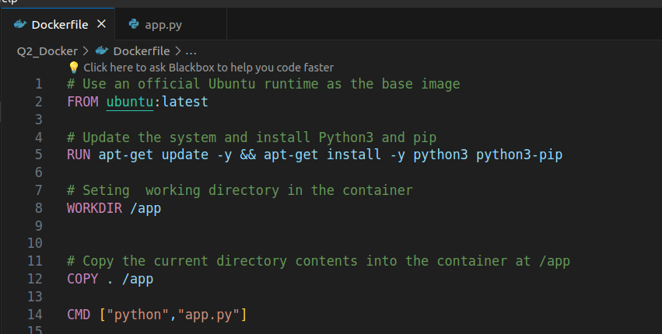
2)Python Script (app.py)
print(“Hello world”)

3)Docker image

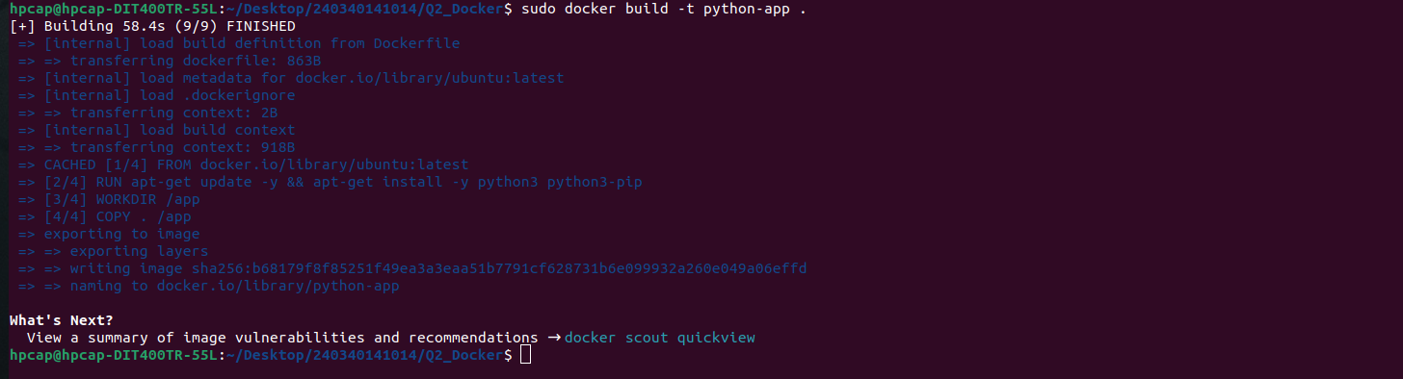

4)Deploy container
5)verify container is running
using docker ps we chekc docker running state

